
HDMI Extender over TCP/IP up to 60m
ND8110HE-60
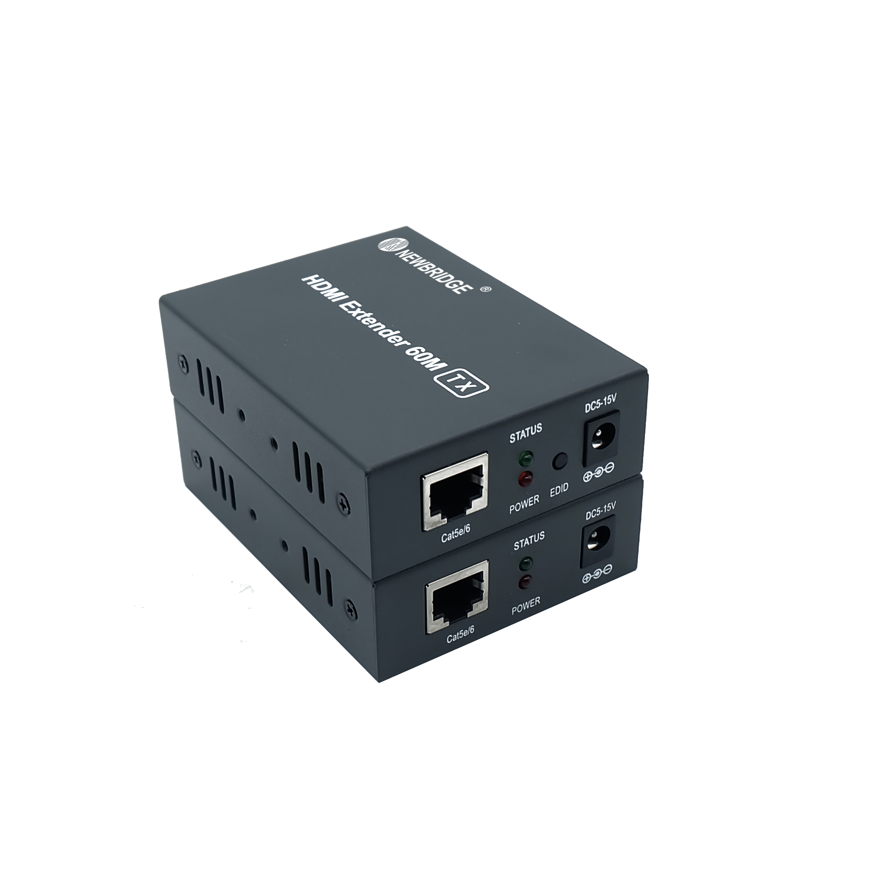
Feature
16-Pot 10/100Mbps +2G TP/SFP Combo
PoE Switch with LCD Display

√ Transmits HDMI video and audio signals up to 60m over a signals CAT6 cable;
√ Support video resolution up to 1920*1200@60Hz, 3D signal;
√ Support copy EDID function, can match many kind display device;
√ Compliance with HDMI 1.3 and HDCP 1.2 standard;
√ High compatibility, can auto-match source and display device;
√ Built-in automatic adjustment system ,make the image smooth ,clear and stable;
√ Built-in ESD protection system;
 Simple to install,plug and play;

Application Diagram
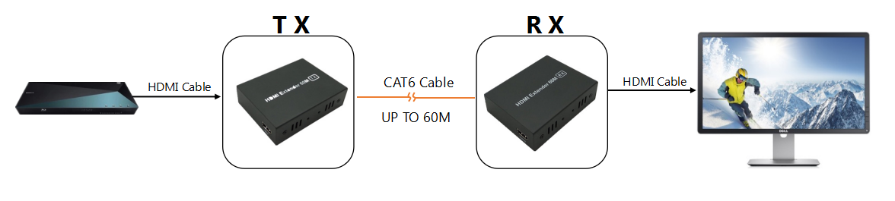

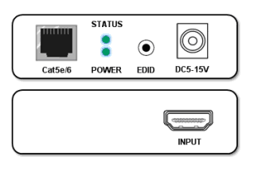
Panel Specifications
Parameter |  | Description
Video | Standards | HDMI 1.3;HDCP 1.2
Video | Maximum pixel clock | 165MHz
Video | Maximum data rate | 6.75Gbps
Video | Resolution range | 1920*1200P@60Hz
Video | Connector | HDMI-A
Video | Impedance | 100Ω
UTP | Interface | RJ45
UTP | Transmission distance | CAT6-60m
Other | Power supply | The power adapter:DC 5-15V
Other | Power dissipation | MAX 3W
Other | Temperature | Operation:-5℃~70℃
Other | Humidity | Operating:5%~90%
Other | Dimension | 94.5*71*26mm
Other | The warranty | 1 year free warranty

Transmitter
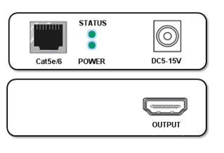

Receiver


Shenzhen Newbridge Communication Equipment CO.,LTD
Tel：+86 755 85292270 Email:info@newbridge.com.cn Website:www.newbridge.com.cn

