
10/100Mbps 4+2 Port 250m PoE Switch
with built-in Power Supply (ND1P402F)

Feature
16-Pot 10/100Mbps +2G TP/SFP Combo
PoE Switch with LCD Display

√ 4*10/100Mbps PoE ports, 2*10/100Mbps uplink port;
√ Support IEEE802.3af/at;
√ Support restrain network storm, VLAN function;
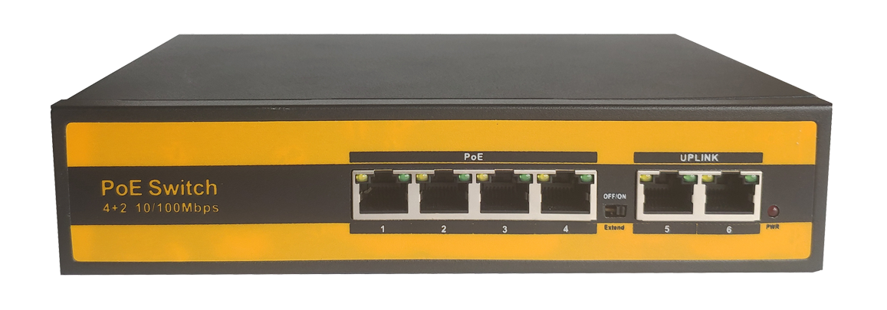
√ Support Max Transmission distance up to 250m with PoE Power;
√ All port supported by MDI/MDIX auto flip and self-negotiation;
√ Built-in power supply;
√ Maximum power of single PoE port: 30W;
√ Maximum PoE power: 75W;
√ Adopts store-and-forward architecture;
√ Fanless, natural cooling, small,compact and quiet design, suitable for desktop or wall;
√ Support lightning protection 6000V;
Technical Data sheet
Power Adapter Voltage |  | AC 110V-240V
Consumption |  | 75W(52V 1.44A)
Network Port | PoE Ethernet Port | 1-4 port:10/100Mbps
Network Port | Ethernet Port | Uplink port:10/100Mbps
Transmission Distance |  | 100Mbps:0-100m  10Mbps:0-250m
 |  | Uplink Port:0-100m
Transmission Medium |  | Cat5/5e/6 standard network cable
Network Standard |  | IEEE802.3/802.3u,IEEE802.3x,IEEE802.3ab
Switching Capacity |  | 1.2Gbps
Packet Buffer Memory |  | 1Mbits
Throughput |  | 0.9Mbps
MAC Table |  | 1K
Packet Forwarding rate |  | 10Mbps:14880pps/port  100Mbps:1488000pps/port
PoE Standard |  | IEEE802.3af/at
PoE Power Supply |  | 12 45 +,36 78 -,8 core power supply
PoE Power |  | af=15.4w,at=30w for each port
Port Function |  | Power priority mechanism,fast and forward,  MAC automatic learning and aging  IEEE802.3X Full-duplex and mode and  backpressure for Half-duplex mode
LED Indicator |  | LINK/ACT.100Mbps;PoE Status Indicator;  Power indicator;Extender
Working temperature |  | 0℃~50℃
Relative Humidity |  | 20-95%
Storage temperature |  | -20℃~70℃
Dimension(L*W*H) |  | 202mm*140mm*45mm
Color |  | Black
Weighr |  | 0.95kg
Diagram
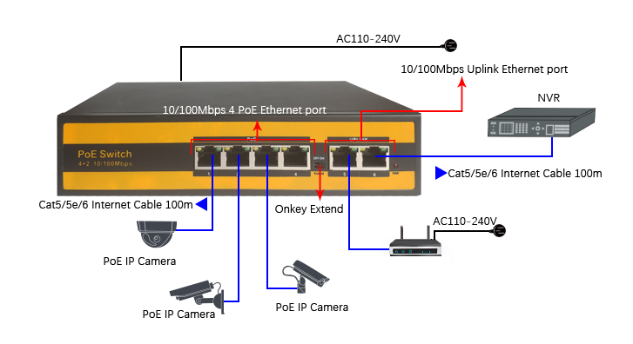

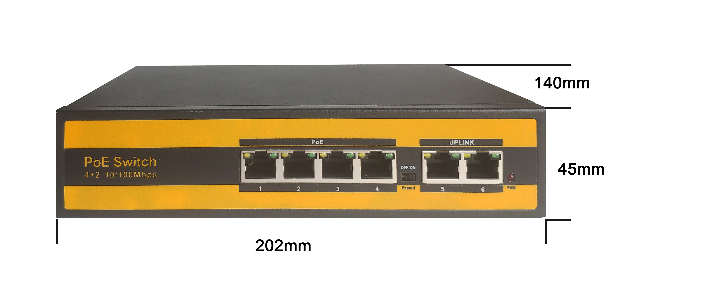
Dimensions


Shenzhen Newbridge Communication Equipment CO.,LTD
Tel：+86 755 85292270 Email:info@newbridge.com.cn Website:www.newbridge.com.cn

